**Technology to support reading**

**PC / laptop**

**Word 2010** has the facility to add speech to read back any text produced or documents. Google ‘how to enable **text to speech** in Microsoft Word 2010’ to help you set that up.

**Open dyslexic** or **dyslexie –** FREE fonts that can be downloaded to support dyslexic readers

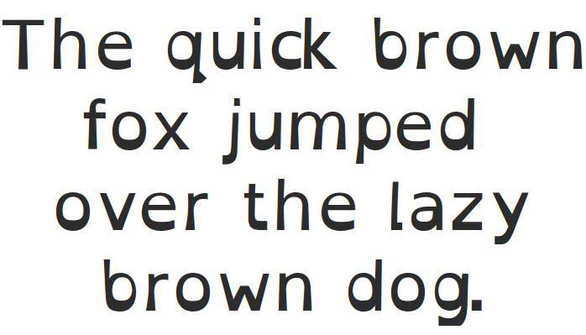

**Natural Reader v15 -** FREE text to speech tool. Floating tool bar. Will read variety of file types including pdf.

**Text Help read&write** – [**www.texthelp.com**](http://www.texthelp.com) - FREE to teachers text to speech tool that can be used on a variety of platforms.

**Accessibility tools for Windows -** Google for information on setting up magnifier, text to speech, font and colour personalisation of your computer screen.

**Useful websites**

**www.oxfordowl.co.uk**

Access to 250 **FREE** ebooks which can be read on PC or tablet. Books are supported by read aloud if desired.

**www.rnibbookshare.org**

RNIB Bookshare is a free online service providing accessible books for reading disabled learners**.** This includes school textbooks, fiction and non-fiction titles which can be downloaded and read with text to speech tools, font/layout changed etc.

**www.bdatech.org**

Useful website on technology to support dyslexic learners

**www.callscotland.org.uk**

CALL Scotland (Communication, Access, Literacy & Learning) has a great range of information and resources around technology to support learners.

**ipad accessibility features**

**Text to speech, speak screen, larger type, invert colours**

Access through ipad - Settings → General → Accessibility

|  |  |
| --- | --- |
| **Apps to support reading** | |
|  | **Claro Scanpen iOS £6.99 / Android £2.99**  Takes a photo of any text and reads it aloud. Select from a variety of voices and speeds. |
|  | **Voice Dream Reader iOS £14.99 / Android £7.99**  Will open and read aloud a wide variety of file types. Highlights text while reading. Dyslexie font available. Try before you buy with **Lite** version. |
|  | **Collins Big Cat books iOS FREE**  Choice of 8 books aimed at 4-6yrs  Choose from having the story read to you or read it yourself. Can record and playback own voice reading. Create a story option for you to make your own version. |
| Jack and the Beanstalk by Nosy Crow | **Nosy Crow Fairy Tales iOS £4.99 each**  Interactive reading experience where gaming and reading meet! |
| C:\Users\acer\Pictures\hairy letters.jpg | **Hairy Letters & Hairy Phonics iOS / Android £2.99**  Multisensory learning of letter names and sounds. |
| C:\Users\acer\Pictures\chimp fu.jpg | **Chimp Fu iOS / Android £2.99**  Great game to practice chunking and syllable division. |