Spelling

Your child will be doing lots of work at school. They are probably tired when they get home, so keep homework time short and specific.

*Link spellings to familiar words **- and, sand, band, strand, grand**

*When ready, add suffixes or prefixes e.g**. fortune, fortunate, unfortunate**

*Tap or clap out the syllables - **count-ing, e-lev-en, round-a-bout**

*Remember spellings by the way they sound .e.g. said **= say id,** stomach = **stow –match**, impatient = **im –pat-ient**

*Find words within words **FAT-HER TO-GET-HER**

*Practise building words with magnetic letters or cards, rather than writing them.

[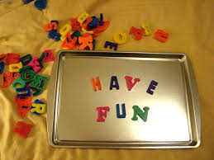](http://www.google.co.uk/imgres?imgurl=http://www.playdatecrashers.com/wp-content/uploads/2013/04/DSC08365-1024x768.jpg&imgrefurl=http://www.playdatecrashers.com/2013/04/cookie-sheet-travel-fun/&h=768&w=1024&tbnid=uAu6FIhr6r9hyM:&zoom=1&docid=0Cn-8J0EuogIVM&hl=en&ei=IkYTVdeJCcvtaNDQguAJ&tbm=isch&ved=0CGMQMyhbMFs4ZA)

* Get outside and bounce a ball as you recite your spellings. Aim the ball at the word chalked on a wall or the ground.

Use Mnemonics – **B**ig **e**lephants **c**an’t **a**lways **u**se **s**mall **e**xits – Because

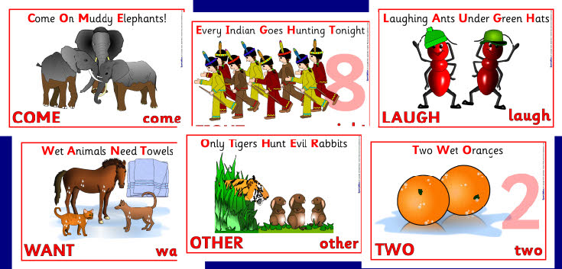

Chunk spellings **Miss iss iss ipp i**

**Tho rough ly**

Make them memorable by writing words Large and In colour

Or add a picture to remember it.

[](http://www.google.co.uk/imgres?imgurl=http://www.wsc.ma.edu/personalpages/draker/edcom/final/sp10/sectiona/spring/FreeSpringClipArt.png&imgrefurl=http://mirandalambertbuzz.blogspot.com/2011/05/thank-you-animation-for-powerpoint-free.html&h=331&w=600&tbnid=O016DN0KjQAQSM:&zoom=1&docid=pXTdy1JhgQGq3M&hl=en&ei=XUsTVaanDsyvadfcgvAB&tbm=isch&ved=0CGEQMyhZMFk4rAI)

Ta